

“Expert Cloud Consulting” - SOP | Azure Database to AWS Database Migration
03.January.2025 version 1.0
—
Contributed by Tejal Kale Approved by Akshay Shinde Expert Cloud Consulting
Office #811, Gera Imperium Rise,
Hinjewadi Phase-II Rd, Pune, India – 411057

“Expert Cloud Consulting”
Azure Database to AWS Database Migration

Contents
- Contents 1
- General Information: 2
  - Document Purpose 2
  - Document Revisions 2
- Document Overview 3
- Project Overview 4
  - Architecture 4
  - Prerequisites 4
  - Project Structure 4
- Product Service (Python/Flask) 5
  - Application Setup 6
  - Requirement.txt 6
  - Dockerfile 6
  - Templates/index.html 6
  - Static/style.css 7
- Order Service (Node.js) 7
  - Package.json 7
  - Server.js 7
  - Dockerfile 8
- Database Setup (MySql) 8
  - db/init/sql 9
- Docker Compose Configuration 9
  - docker.compose.yml 9
- Running Apllication 10



General Information:

Document Purpose

This document serves as a detailed roadmap for organizations looking to migrate their databases from Azure to AWS. It includes best practices, AWS migration tools, and step-by-step instructions to ensure a successful migration with minimal downtime and optimal performance.

Date | Versio n | Contributor(s) | Approver(s) | Section(s) | Change(s)
03/Jan/2025 | 1.0 | Tejal Kale | Akshay Shinde | All Sections | New Document Created

Document Overview:

This document provides a step-by-step guide for migrating databases from Microsoft Azure to Amazon Web Services (AWS) using AWS Database Migration Service (AWS DMS). It covers migration strategies, tools, and best practices to ensure a smooth, secure, and efficient transition of databases from Azure to AWS.

Project Overview:

Architecture

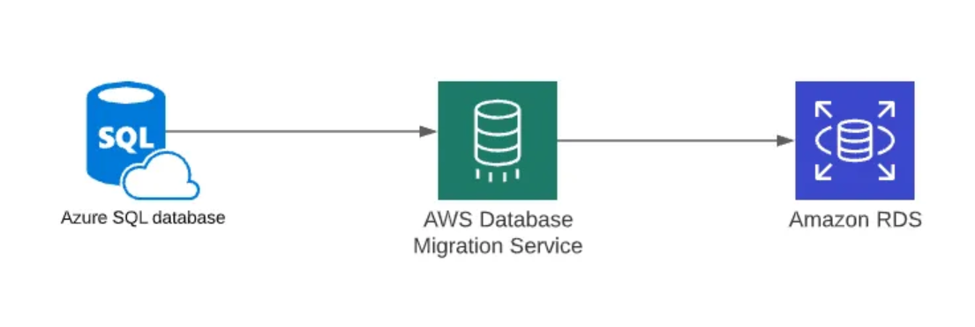

5.0 Create Azure SQL single database instance

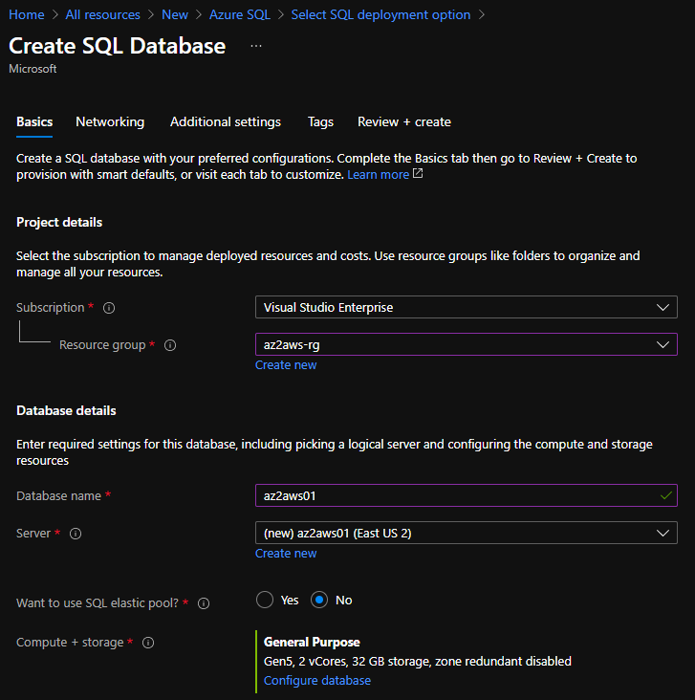

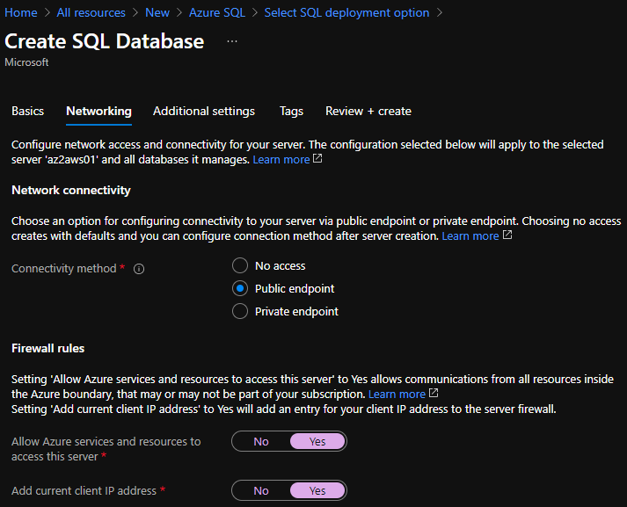

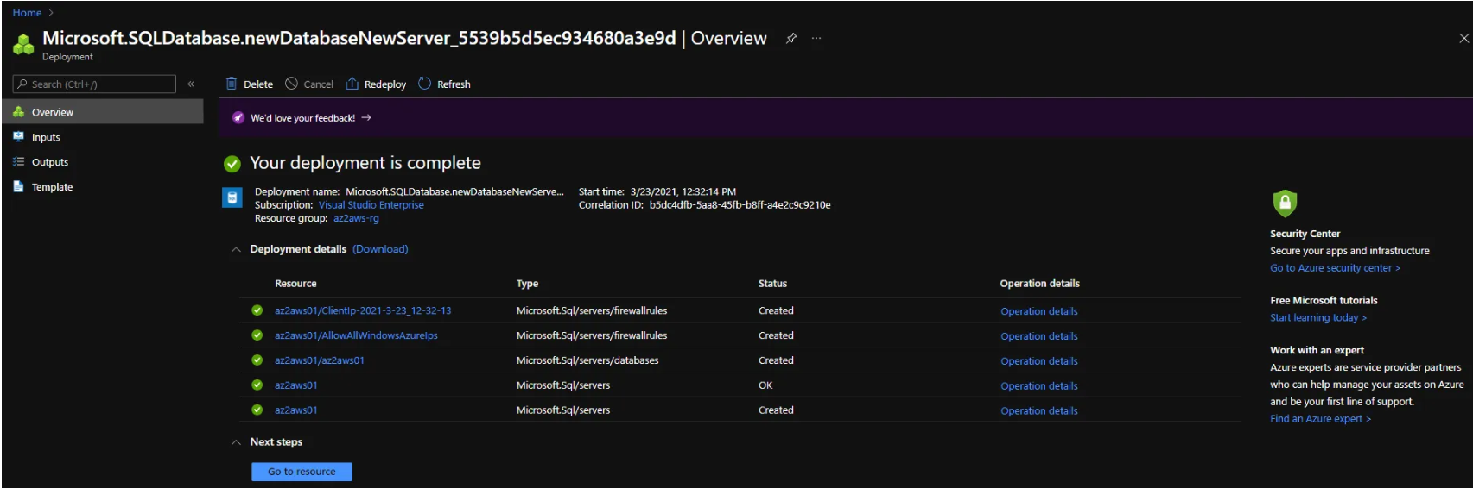

5.1 Create Amazon RDS for SQL Server database instance
chose to go with “Easy Create” database creation method as it saves time in the creation process. Some of the default settings applied during database creation can be modified later.

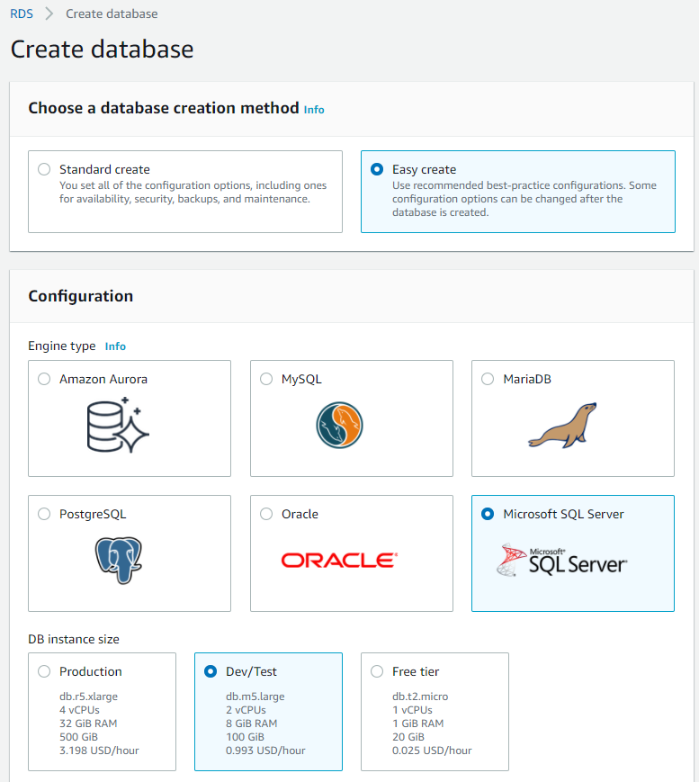
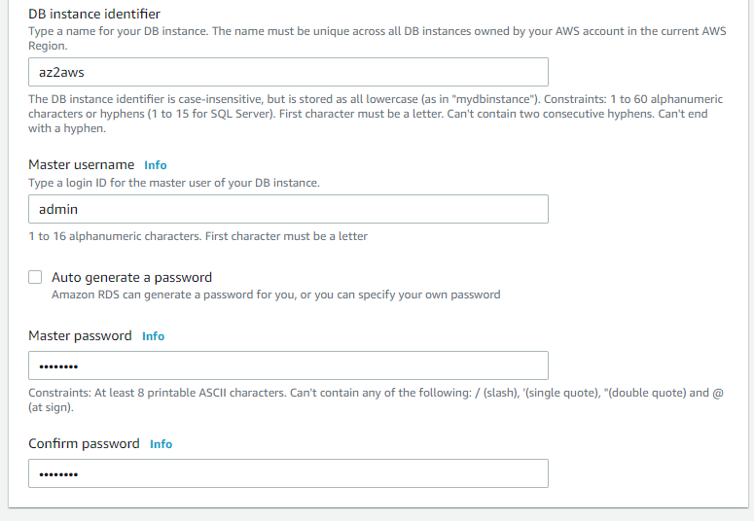
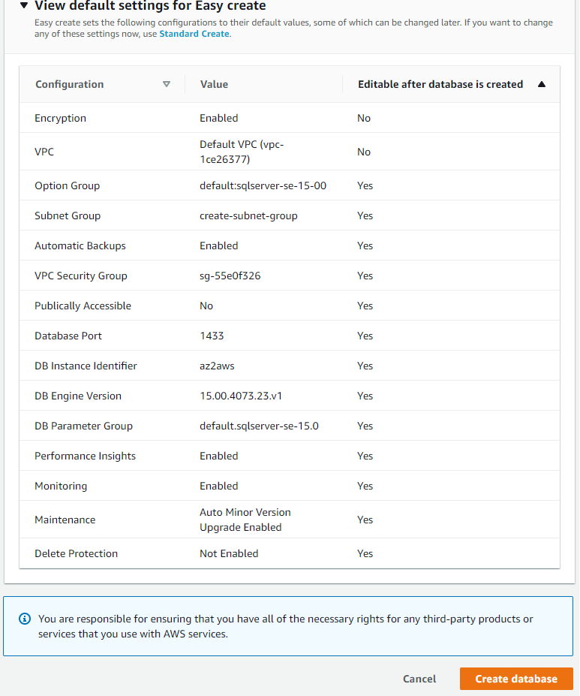

6.0 Create AWS Data Migration Service (DMS) replication instance

DMS replication instance’s performance depends on the “Instance class”. This has to be chosen carefully
based on the source workload.

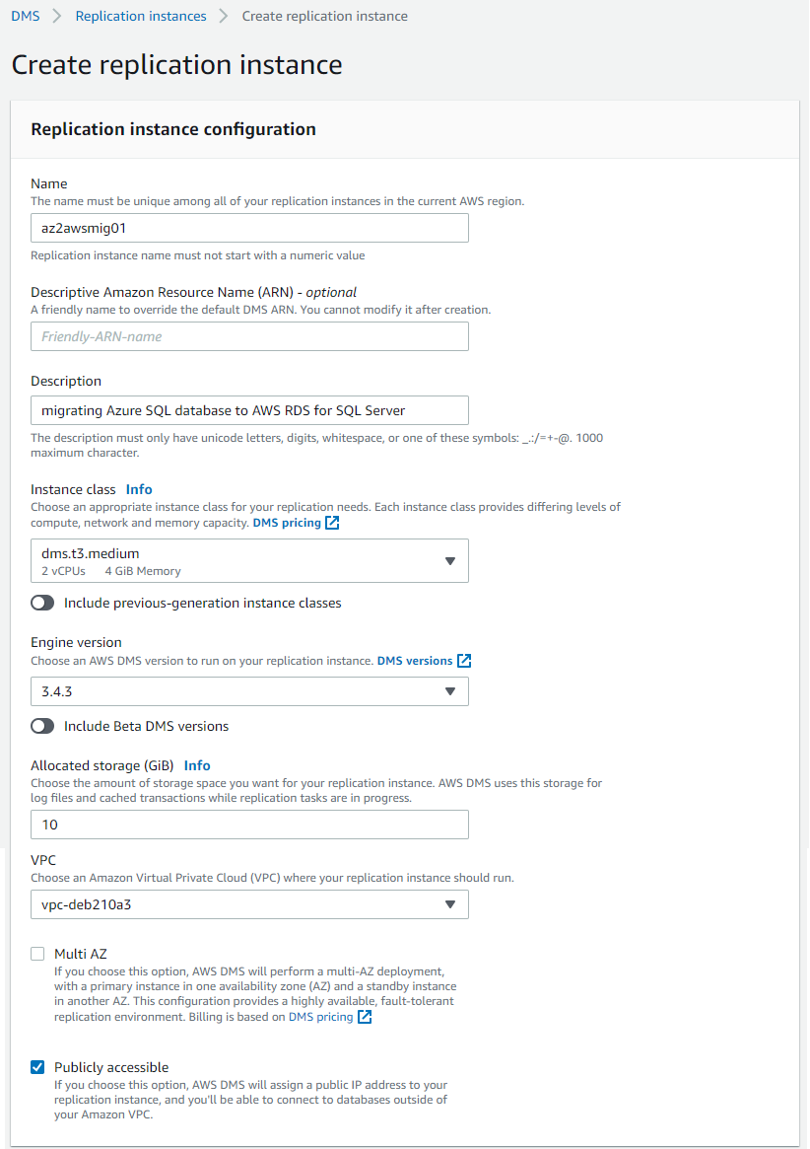

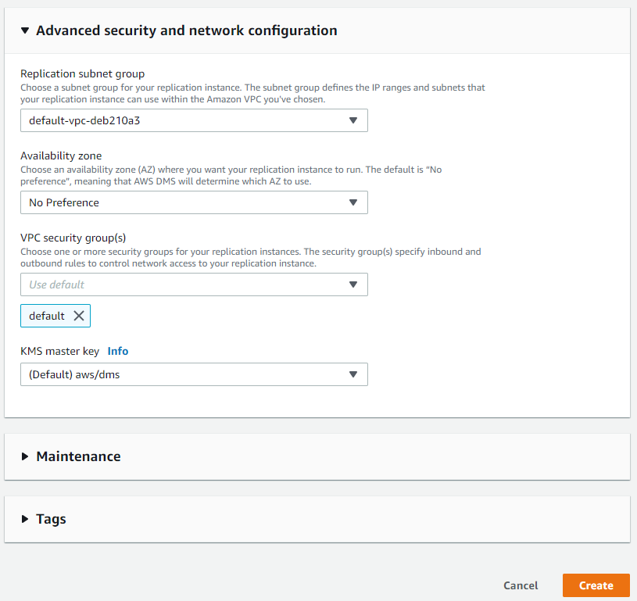
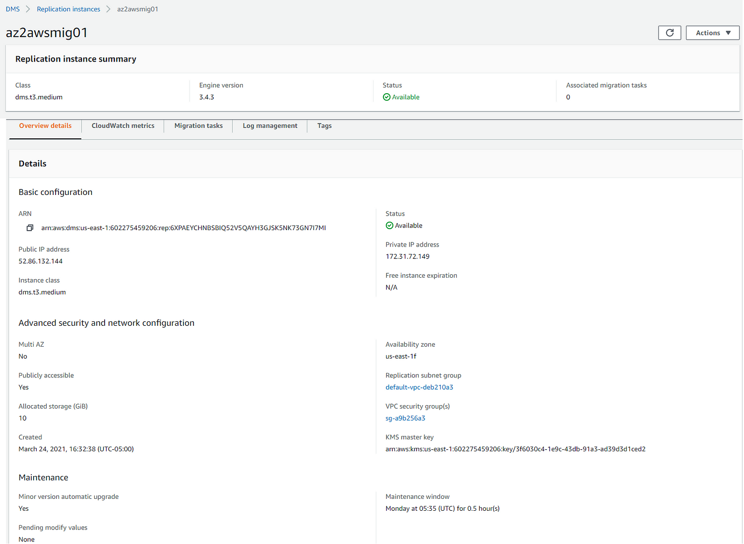

Create database migration tasks
These are the steps involved in creating database migration tasks.
- Create Source endpoint
- Create Target endpoint
- Create database migration tasks

Create Source endpoint

Before creating the endpoint for Azure SQL instance, a new firewall rule has to be added to Azure SQL server
to allow the access from AWS DMS replication instance’s Public IP address.

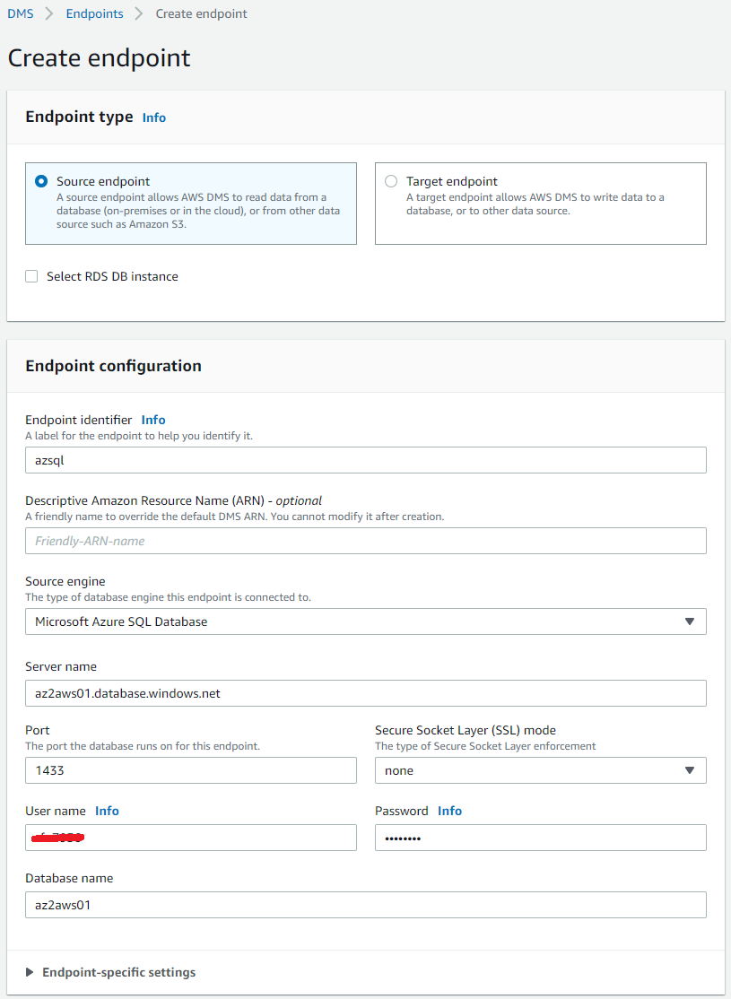

Create Target endpoint
create an empty database “azsql” in the instance, by logging into the instance using SSMS. These details must be entered in SSMS to connect to the Amazon RDS for SQL Server database instance.
- Server type: Database Engine
- Server name: <endpoint>,<port>
- Authentication: SQL Server Authentication
- Login: <Master username>
- Password: <Master password>

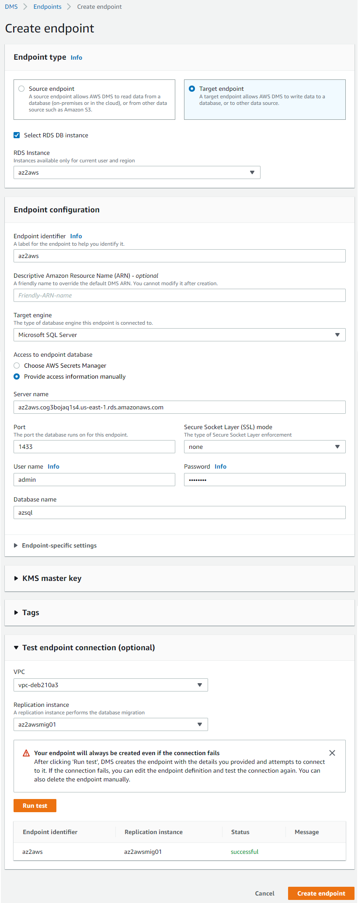



Create database migration tasks
AWS DMS provides 3 options for “Migration type”.
- Migrate existing data
- Migrate existing data and replicate ongoing changes
- Replicate data changes only
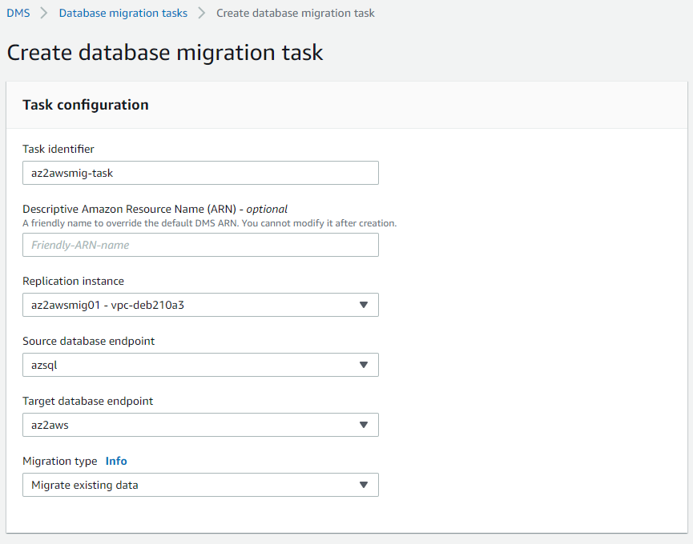

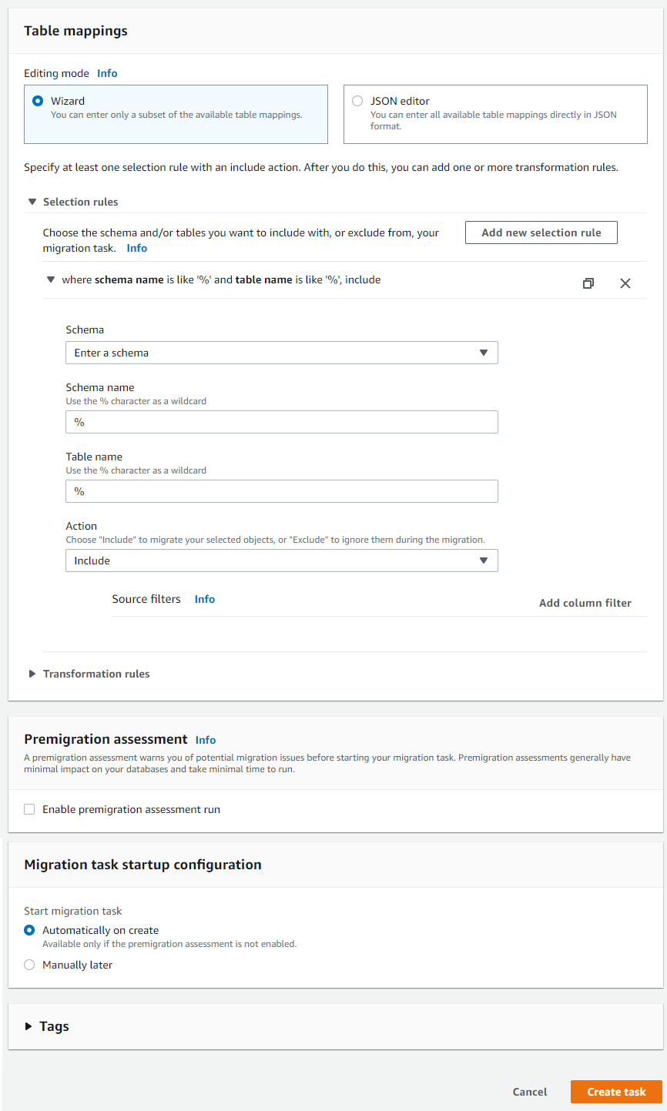

Perform database migration from Azure SQL to Amazon RDS for SQL Server using AWS DMS
Database migration process starts automatically once the migration task is created.
